Balloon Sat Early Release Schematic

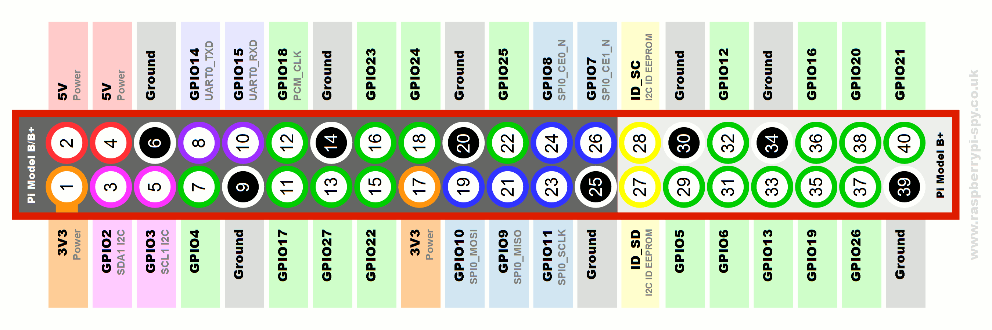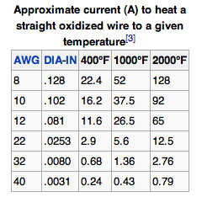

Nichrome Wire Temperature Guide

GPIO Pin configuration close-up.

<https://www.jacobs-online.biz/nichrome/NichromeCalc.html>

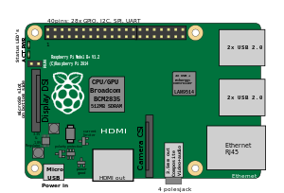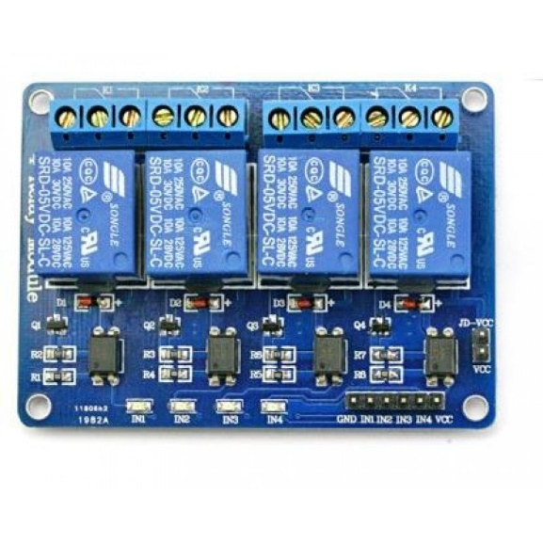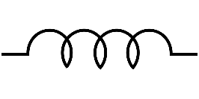

The Raspberry Pi is connected to the Hamshield/Arduino using a serial cable. Monitor, keyboard and mouse can be connected directly to the Raspberry Pi.

Raspberry Pi

Power Source

4 Module Relay Switch designed for the Raspberry Pi

Nichrome Wire

Nichrome Wire

Nichrome Wire

Nichrome Wire